Module 5 - Spring Core and Maven
Exercise 1: Configuring a Basic Spring Application

Pom.xml:
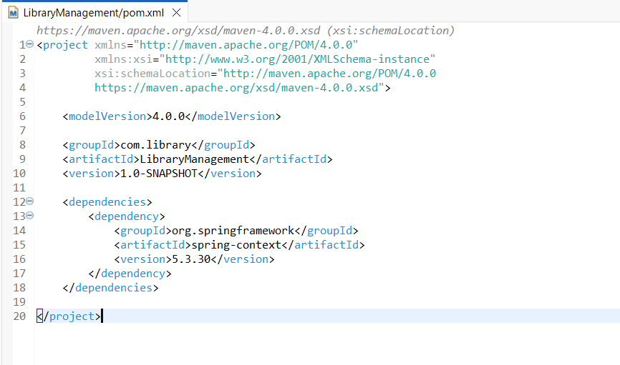
LibraryMain.java:
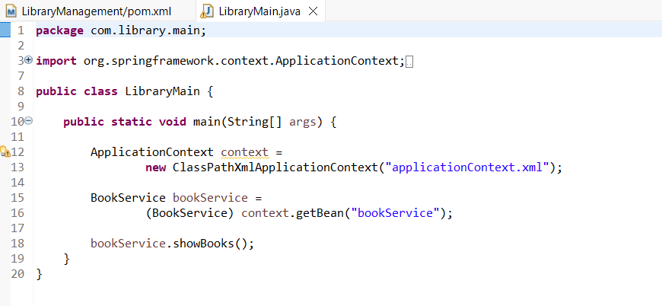
BookRepository.java:
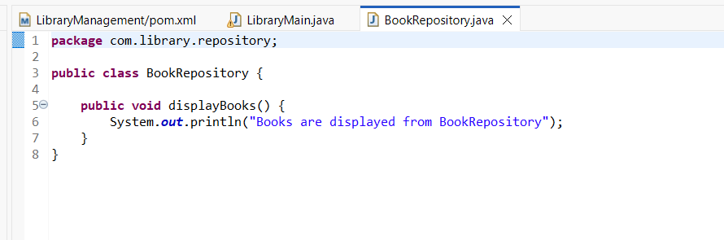
BookService.java:
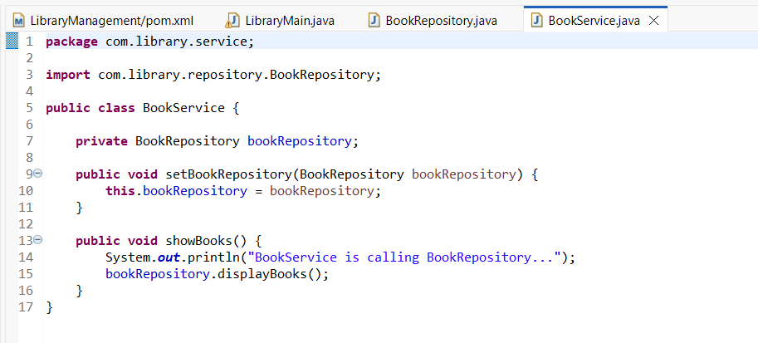
Output:
